

**WAEP Semester One Examination, 2018**

**Question/Answer booklet**

**MATHEMATICS**

**METHODS UNIT 1**

**Section One: Calculator-free**

If required by your examination administrator, please place your student identification label in this box

Student number: In figures

|  |  |
| --- | --- |

|  |  |  |
| --- | --- | --- |

|  |  |  |
| --- | --- | --- |

In words ______________________________________

Your name ______________________________________

**Time allowed for this section**

Reading time before commencing work: five minutes

Working time: fifty minutes

**Materials required/recommended for this section**

***To be provided by the supervisor***

This Question/Answer booklet

Formula sheet

***To be provided by the candidate***

Standard items: pens (blue/black preferred), pencils (including coloured), sharpener, correction fluid/tape, eraser, ruler, highlighters

Special items: nil

**Important note to candidates**

No other items may be taken into the examination room. It is **your** responsibility to ensure that you do not have any unauthorised material. If you have any unauthorised material with you, hand it to the supervisor **before** reading any further.

**METHODS UNIT 1 2 CALCULATOR-FREE**

**Structure of this paper**

| Section | Number of questions  available | Number of  questions to be answered | Working  time  (minutes) | Marks  available | Percentage of  examination |
| --- | --- | --- | --- | --- | --- |
| Section One:  Calculator-free | 8 | 8 | 50 | 52 | 35 |
| Section Two:  Calculator-assumed | 13 | 13 | 100 | 98 | 65 |
|  |  |  |  | **Total** | 100 |

**Instructions to candidates**

1. The rules for the conduct of examinations are detailed in the school handbook. Sitting this examination implies that you agree to abide by these rules.

2. Write your answers in this Question/Answer booklet.

3. You must be careful to confine your response to the specific question asked and to follow any instructions that are specified to a particular question.

4. Supplementary pages for the use of planning/continuing your answer to a question have been provided at the end of this Question/Answer booklet. If you use these pages to continue an answer, indicate at the original answer where the answer is continued, i.e. give the page number.

5. Show all your working clearly. Your working should be in sufficient detail to allow your answers to be checked readily and for marks to be awarded for reasoning. Incorrect answers given without supporting reasoning cannot be allocated any marks. For any question or part question worth more than two marks, valid working or justification is required to receive full marks. If you repeat any question, ensure that you cancel the answer you do not wish to have marked.

6. It is recommended that you do not use pencil, except in diagrams. 7. The Formula sheet is not to be handed in with your Question/Answer booklet.

**See next page** SN078-112-1

**CALCULATOR-FREE 3 METHODS UNIT 1**

**Section One: Calculator-free 35% (52 Marks)**

This section has **eight (8)** questions. Answer **all** questions. Write your answers in the spaces provided.

Working time: 50 minutes.

**Question 1 (5 marks)** (a) Solve 5(2�� + 1) − 3(�� − 4) = 0 for ��. (2 marks)

(b) Solve 7

�� − 5−34��= 0 for ��. (3 marks)

SN078-112-1 **See next page**

**METHODS UNIT 1 4 CALCULATOR-FREE**

**Question 2 (5 marks)** Solve the following equations.

(a) 6��2 = 3��. (2 marks) (b) ��(�� + 2) = 24. (3 marks)

**See next page** SN078-112-1

**CALCULATOR-FREE 5 METHODS UNIT 1**

**Question 3 (6 marks)** A function is defined by ��(��) = √3��.

(a) Calculate ��(12). (1 mark) (b) State the domain and range of ��(��). (2 marks)

(c) Sketch the graph of �� = ��(��) on the axes below. (3 marks)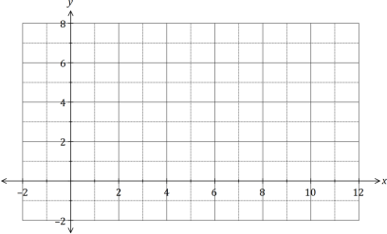

SN078-112-1 **See next page**

**METHODS UNIT 1 6 CALCULATOR-FREE**

**Question 4 (5 marks)** The graph of the line ��1 is shown below.

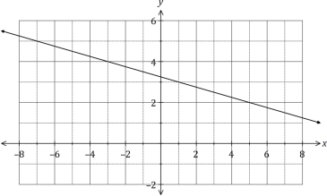(a) Determine the equation of ��1. (2 marks)

Two points are located at ��(−10, 5) and ��(6, 29).

(b) Line ��2 is perpendicular to ��1 and passes through the mid-point of �� and ��. Determine the equation of ��2. (3 marks)

**See next page** SN078-112-1

**CALCULATOR-FREE 7 METHODS UNIT 1**

**Question 5 (6 marks)** (a) Expand and simplify (�� + 2)(2�� − 5)(�� − 2). (2 marks)

(b) One solution to the equation ��3 + 36 = 5��2 + 12�� is �� = 2. Determine all other solutions. (4 marks)

SN078-112-1 **See next page**

**METHODS UNIT 1 8 CALCULATOR-FREE**

**Question 6 (9 marks)** (a) Solve the equation √3 tan(��) − 3 = 0 for 0 ≤ �� ≤ 2��. (3 marks)

(b) A function has a period of �� and is defined by ��(��) = 4 cos(2��).

(i) State the value of ��. (1 mark) (ii) State the amplitude of ��(��). (1 mark)

(iii) Sketch the graph of �� = ��(��) over the domain −�� ≤ �� ≤ ��. (4 marks)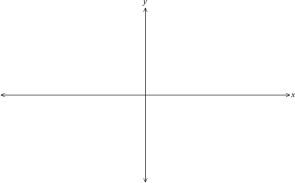**See next page** SN078-112-1

**CALCULATOR-FREE 9 METHODS UNIT 1**

**Question 7 (9 marks)**

(a) The tenth row of Pascal's triangle begins with the numbers 1, 10, 45, 120, 210, 252 and so on.

(i) State the value of (104). (1 mark) (ii) Deduce the value of (113). (2 marks)

(iii) Calculate the sum of all the terms in the ninth row of Pascal's triangle. (2 marks)

(b) The coefficient of the ��2term in ��3 + 5��2 − 3�� + 1 is 5. Determine the coefficient of the ��2 term in the expansion of

(i) (3�� − 5)2. (1 mark) (ii) (2�� + 2)4. (3 marks)

SN078-112-1 **See next page**

**METHODS UNIT 1 10 CALCULATOR-FREE**

**Question 8 (7 marks)**

(a) The graph of the relation ��2 = �� passes through the points (16, ��) and (��, −5). Determine the values of �� and ��. (3 marks)

(b) Another relation is defined by (�� − 1)2 + (�� + 2)2 = 4.

(i) Sketch the graph of this relation on the axes below. (3 marks) 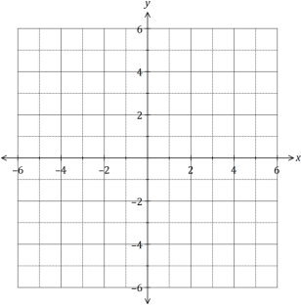

(ii) What feature of the graph indicates that a relation rather than a function is shown? (1 mark)

**End of questions** SN078-112-1

**CALCULATOR-FREE 11 METHODS UNIT 1** Supplementary page

Question number: _________

© 2018 WA Exam Papers. Perth Modern School has a non-exclusive licence to copy and communicate this document for non-commercial, educational use within the school. No other copying, communication or use is permitted without the express written permission of WA Exam Papers. SN078-112-1.